**Recognizing Parts of a Check**

When accepting checks as payment, always review the check and make sure all required parts are included. If a check is presented in person, request to see the student’s ID card or a state-issued photo ID.

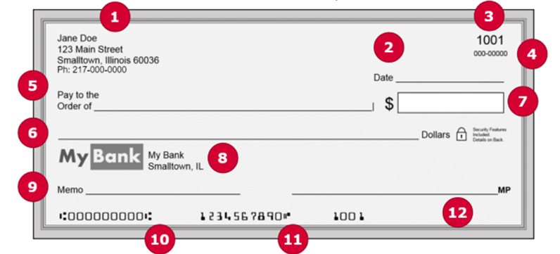

1. The payer name and address. A telephone number is also recommended.
2. Current date. Do not accept post-dated checks, or checks dated more than 30 days prior to current date.
3. The check number.
4. The fraction code. It denotes the bank routing number.
5. The payee. It should be payable to the University of Illinois.
6. The written amount of the check. It must match the numeric amount. If it does not match, request a new check or another form of payment.
7. The numeric amount.
8. The bank name, city and state. Only accept checks due and payable in United States currency.
9. The memo line. If payment is from a student, the student’s UIN should be listed.
10. The bank routing number.
11. The bank account number.
12. The signature line and signature.

The below check looks good.

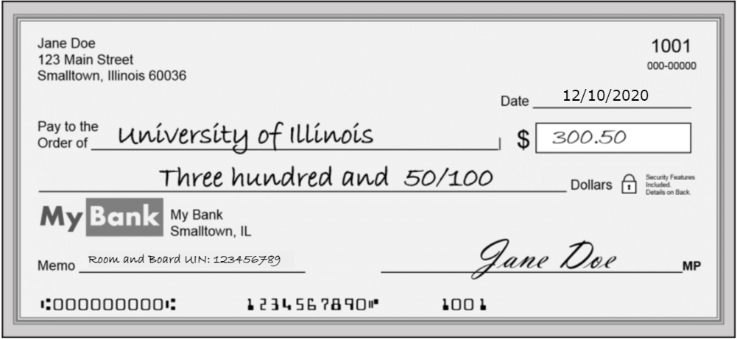

**Endorsing a Check:**

If the check is correctly filled out, immediately endorse the back of the check with your department’s endorsement stamp, in the ‘Endorse Here’ area. Your department’s endorsement stamp should include the following information:

1. For Deposit Only
2. Department Name
3. Department C-FOAPAL*

*UIUC Cash Handling Units may provide the department form reference number in lieu of C-FOAPAL.

See below for an example: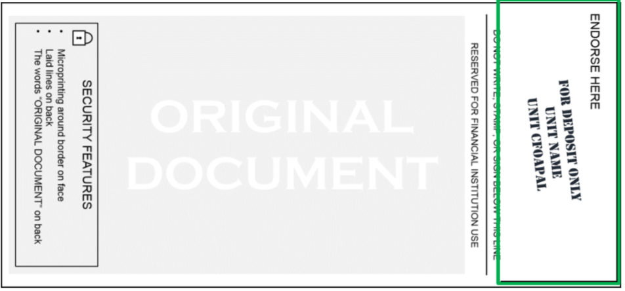

**Preparing to Accept Cash Payments:**

Before you begin accepting cash payments, be sure to do the following:

1. Count your cash drawer at the start of your sales day or shift.
2. Count your cash drawerbefore beginning sales for the day.
3. Ensure you have a way to provide receipts for payment.

**Steps for Accepting Cash Payments**

* Only accept United States currency
* Count cash in front of the customer
  + Verify correct payment amount for item(s) and determine if change is needed
  + Verify cash is not counterfeit
  + When receiving large sums of cash, it is a recommended practice to have another front-line staff member verify the funds
* Process payment
* Make change as needed and count change back to customer.
* Write or print receipt and provide to customer. Keep copy or carbon copy for file.
* Secure cash in drawer, safe, etc.

For more information about screening cash transactions for counterfeit currency, please learn more at:

<https://www.uscurrency.gov/>. For more information on what to do if you encounter counterfeit currency, please refer to: <https://www.busfin.uillinois.edu/bfpp/section-10-cash-handling/what-to-do-if>.

**Receipt Process**

Always give a receipt to your customer. If your department handwrites receipts because you do not have a cash register or other cashier software, the University Bursar recommends using pre-numbered, carbon-copy receipt for all customer payments.

Enter in the following information on the receipt:

* Date
* Person/company name
* Reason for payment
* Dollar amount
* Form of payment (cash, check, credit card – if applicable)
* Signature of person accepting payment

**Security:**

Keep each cashier’s cash drawer accessible by that cashier only. Lock cash and/or checks in a fireproof safe or cabinet when it is not possible to deposit them that day.

**University Deposit Policy**

To comply with university cash handling policy, all cash handling units must deposit cash and checks within three (3) business days of receiving the funds whenever the unit has collected $5,000 or more, or within five (5) business days of receiving the funds whenever the unit has collected funds totaling less than $5,000.

**Deposit Process Overview:**

* Balance Your Cash Drawer at the end of each day.
* Count the cash and checks to be deposited. Verify that all of the money received is presented for deposit.
* Prepare the deposit. Complete a department deposit form. Department deposit form can be found [here](https://www.obfs.uillinois.edu/common/pages/DisplayFile.aspx?itemId=94553).
* Deliver the deposit to the University Bursar Cashier Office.

**Procedures for Handling a Robbery:**

During a robbery, do your best to do the following:

* Remain calm and comply with all requests made by the perpetrator(s).
* Try to notice and remember any descriptive features or distinguishing marks on the perpetrator(s), such as:
  + Clothing (hats, shoes, jewelry, coat, etc.)
  + Estimated height and physical build
  + Hair color and length, eye color, scars, tattoos, piercings
  + Voice, manner of speaking, voice inflection (accents)
  + Physical mannerisms such as a limp, tick, or otherwise notable attributes, etc.

These details could prove very helpful in catching the perpetrator(s).

* Determine a direction of escape, if it is safe to observe.
* Trip the alarm to University Police as soon as it is safe to do so.
* Do not discuss the robbery with anyone until police arrive.
* Cooperate with the University Police at all times.
* Employees who were present during the robbery should, above all else, remain calm and try to remember the details of the perpetrator(s). After the incident, write down the details on any piece of paper you can find. Provide this information to the University Police.